import React, { useState } from 'react';

function CurrencyConvertor() {

  const [amount, setAmount] = useState('');

  const [currency, setCurrency] = useState('');

  const handleSubmit = (e) => {

    e.preventDefault();

    if (currency.toLowerCase() === 'euro') {

      const convertedAmount = parseFloat(amount) \* 80;

      alert(`Converting to ${currency} Amount is ${convertedAmount}`);

    } else {

      alert('Currency not supported');

    }

  };

  return (

    <div>

      <h1 style={{ color: 'green' }}>Currency Convertor!!!</h1>

      <form onSubmit={handleSubmit}>

        <label>Amount: </label>

        <input

          type="text"

          value={amount}

          onChange={(e) => setAmount(e.target.value)}

        />

        <br /><br />

        <label>Currency: </label>

        <textarea

          value={currency}

          onChange={(e) => setCurrency(e.target.value)}

        />

        <br /><br />

        <button type="submit">Submit</button>

      </form>

    </div>

  );

}

export default CurrencyConvertor;

import React, { useState } from 'react';

import CurrencyConvertor from './components/CurrencyConvertor';

function App() {

  const [count, setCount] = useState(5);

  const incrementAndGreet = () => {

    setCount(count + 1);

    sayHello();

  };

  const sayHello = () => {

    alert("Hello! Member1");

  };

  const decrement = () => {

    setCount(count - 1);

  };

  const sayWelcome = (message) => {

    alert(message);

  };

  const handleClick = () => {

    alert("I was clicked");

  };

  return (

    <div style={{ margin: '20px' }}>

      <p>{count}</p>

      <button onClick={incrementAndGreet}>Increment</button>

      <br /><br />

      <button onClick={decrement}>Decrement</button>

      <br /><br />

      <button onClick={() => sayWelcome("welcome")}>Say welcome</button>

      <br /><br />

      <button onClick={handleClick}>Click on me</button>

      <br /><br />

      <CurrencyConvertor />

    </div>

  );

}

export default App;

OUTPUT:

Hello! Member1

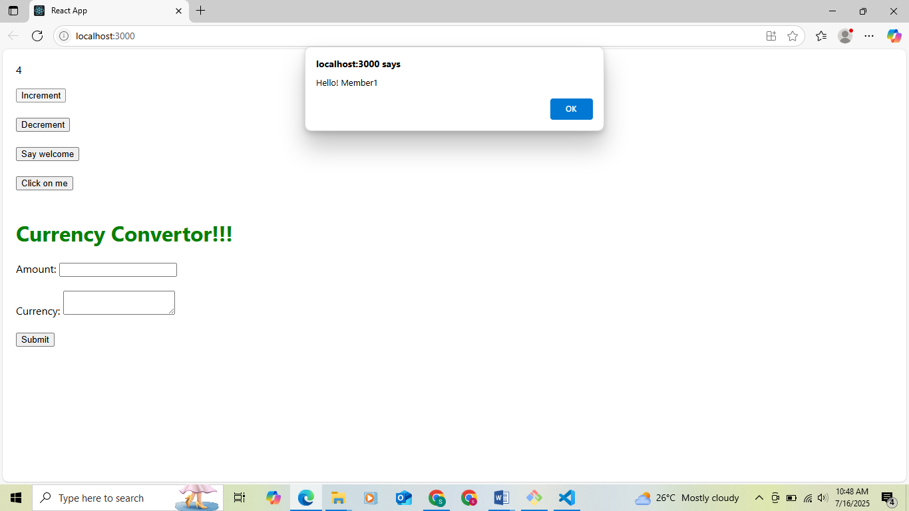

Welcome

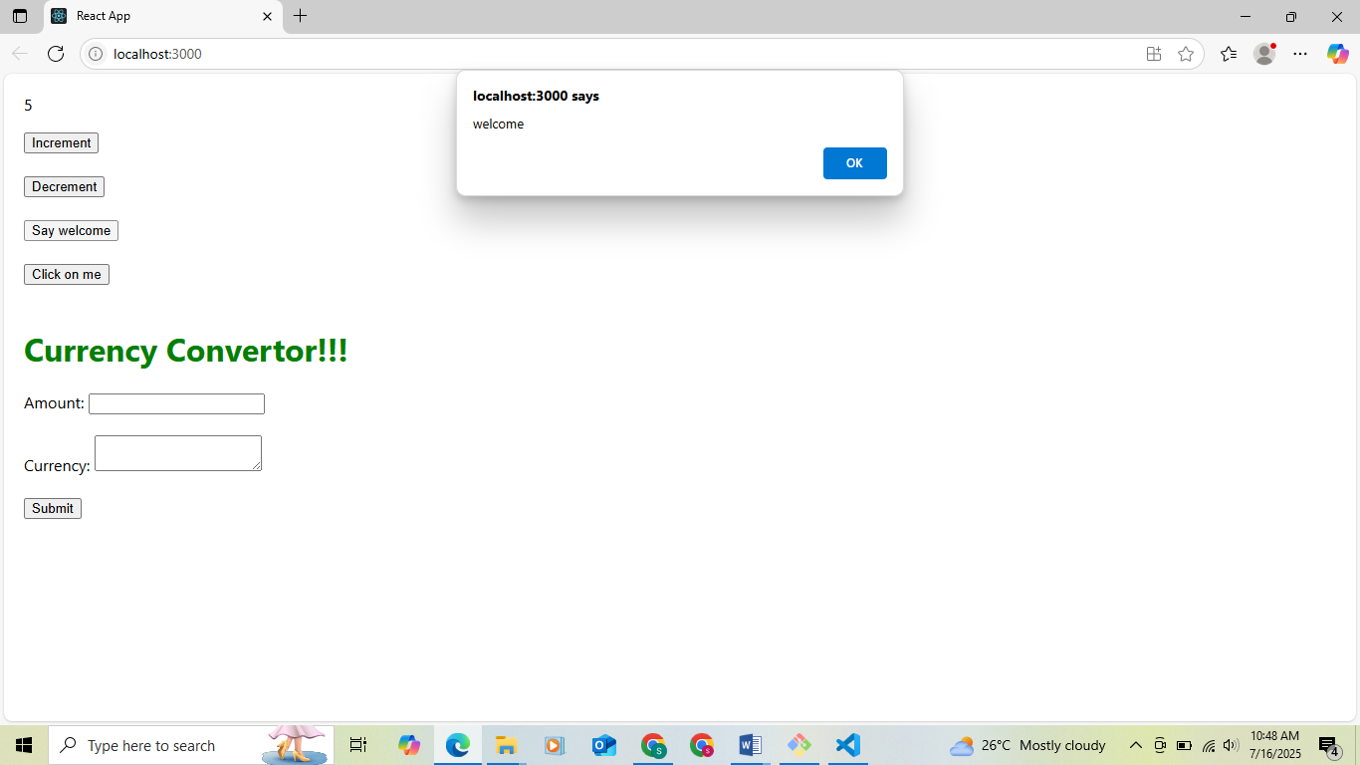

I was clicked

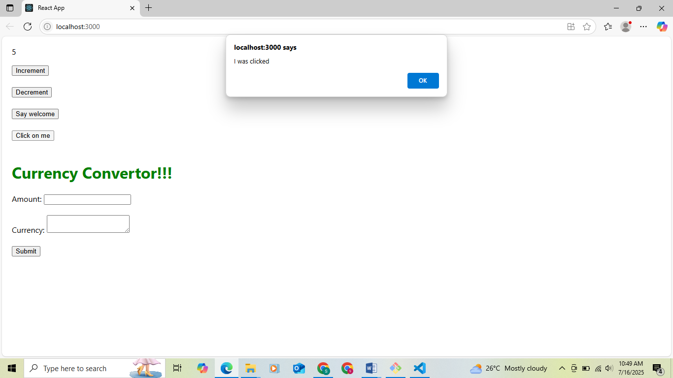

Convertion

